**Sql Assignment 3**

1. Write a SQL query to find Employees who have the biggest salary in their Department.

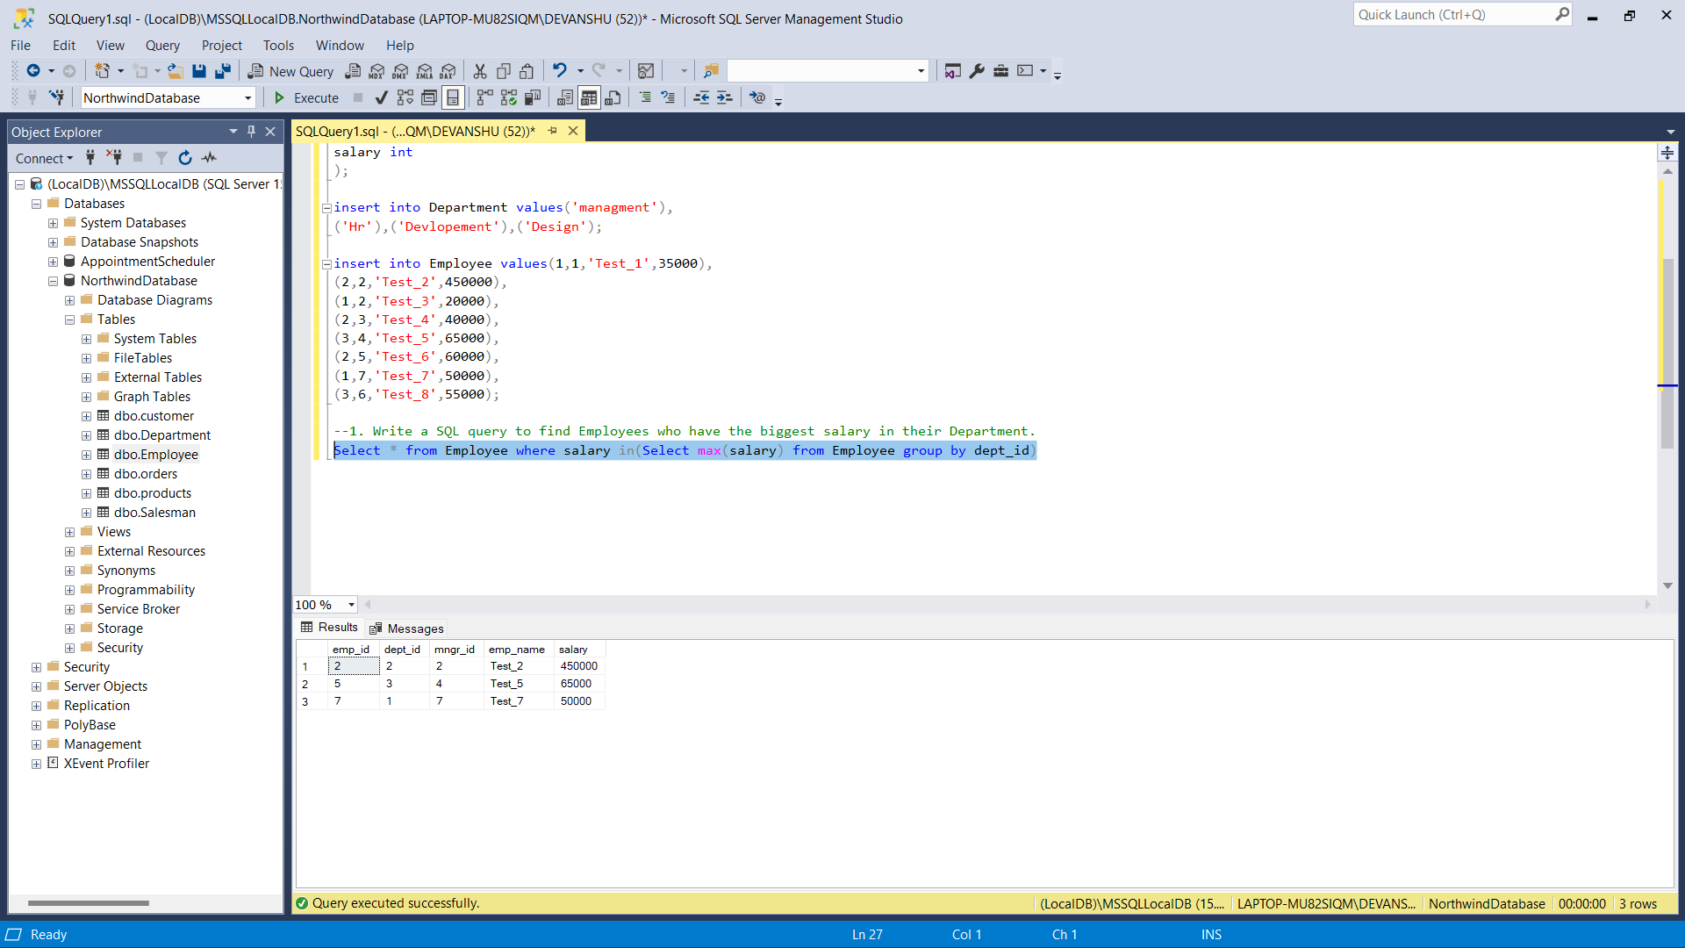

1. Write a SQL query to find Departments that have less than 3 people in it.

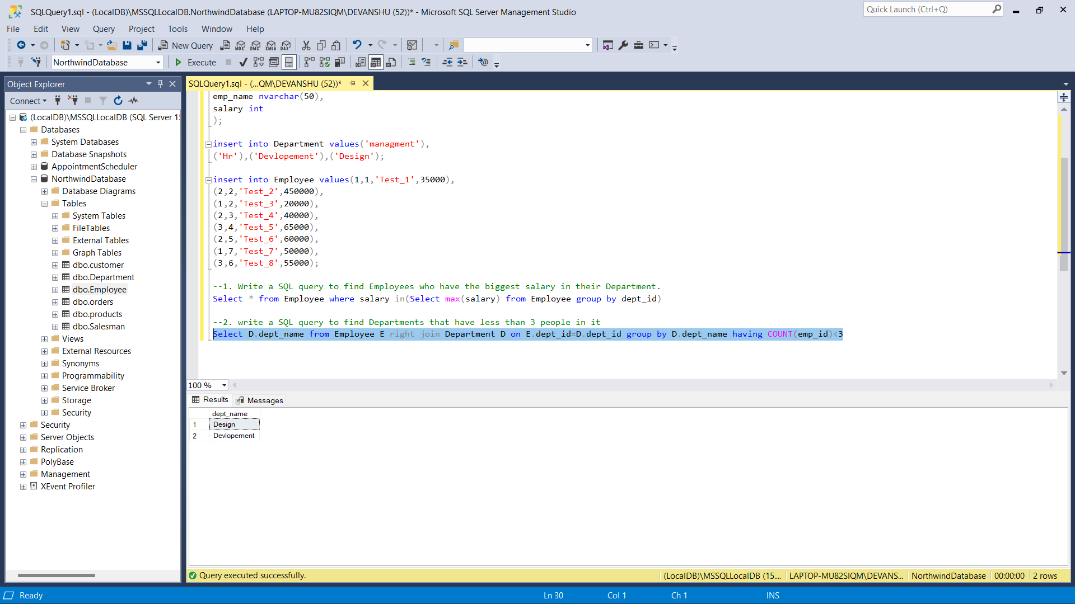

1. Write a SQL query to find All Department along with the number of people there.

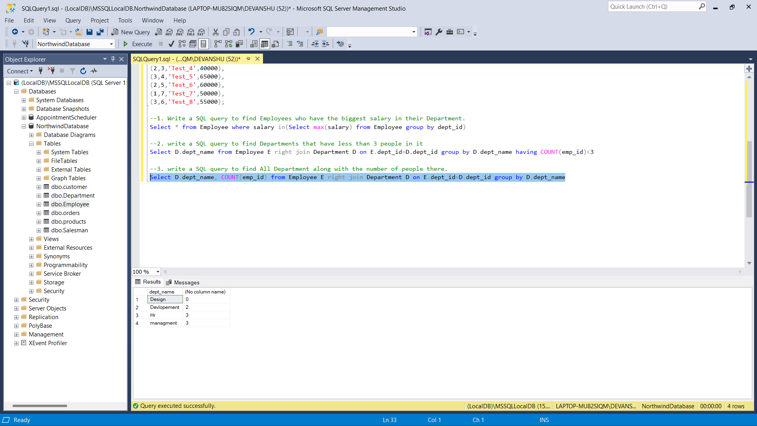

1. Write a SQL query to find All Department along with the total salary there.

